 | U.S. Department of Labor |  |  |  | 
Occupational Safety & Health Administration
Top of Form

 | www.osha.gov |  | MyOSHA[skip navigational links] | Search | Advanced Search | A-Z Index | Bottom of Form

Construction > Construction Outreach TOC > Classification of Portable Fire Extinguishers
Construction Safety and Health  Outreach Program | U.S. Department of Labor  OSHA Office of Training and Education  May 1996
Classification of Portable Fire Extinguishers
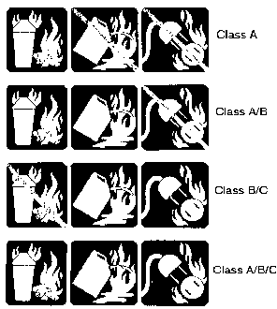
Portable fire extinguishers are classified to indicate their ability to handle specific classes and sizes of fires. Labels on extinguishers indicate the class and relative size of fire that they can be expected to handle.
Class A extinguishers are used on fires involving ordinary combustibles, such as wood, cloth, and paper. Class B extinguishers are used on fires involving liquids, greases, and gases. Class C extinguishers are used on fires involving energized electrical equipment. Class D extinguishers are used on fires involving metals such as magnesium, titanium, zirconium, sodium, and potassium.
The recommended marking system to indicate the extinguisher suitability according to class of fire is a pictorial concept that combines the uses and non-uses of extinguishers on a single label. This system is illustrated in the accompanying figure. The first set (row) of symbols illustrated in the figure is a label for use on a Class A extinguisher. The symbol at the left (which depicts a Class A fire) is blue. Since the extinguisher is not recommended for use on Class B or C fires, the remaining two symbols (which depict Class B and Class C fires) are black, with a diagonal red line through them. The second set (row) of symbols illustrated in the figure is a label for use on a Class A/B extinguisher. The two left symbols are blue. Since the extinguisher is not recommended for use on Class C fires, the symbol on the far right (which depicts a Class C fire) is black, with a diagonal red line through it. The third set of symbols is a label for use on Class B/C extinguishers. The two right symbols are blue. Since the extinguisher is not recommended for use on Class A fires, this symbol is black, with a diagonal red line through it. The fourth set of symbols is a label for use on Class A/B/C extinguishers. All symbols on this label are blue.
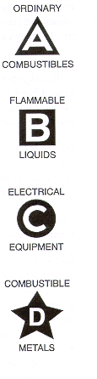
Letter-shaped symbol markings are also used to indicate extinguisher suitability according to class of fire.
Extinguishers suitable for Class A fires should be identified by a triangle containing the letter "A." If colored, the triangle should be green.
Extinguishers suitable for Class B fires should be identified by a square containing the letter "B." If colored, the square shall be colored red.
Extinguishers suitable for Class C fires should be identified by a circle containing the letter "C." If colored, the circle should be colored blue.
Extinguishers suitable for fires involving metals should be identified by a five-pointed star containing the letter "D." If colored, the star shall be colored yellow.
Extinguishers suitable for more than one class of fire should be identified by multiple symbols placed in a horizontal sequence.
Class A and Class B extinguishers carry a numerical rating to indicate how large a fire an experienced person can put out with the extinguisher. The ratings are based on reproducible physical tests conducted by Underwriters' Laboratories, Inc. Class C extinguishers have only a letter rating because there is no readily measurable quantity for Class C fires which are essentially Class A or B fires involving energized electrical equipment. Class D extinguishers likewise do not have a numerical rating. Their effectiveness is described on the faceplate.
Class A Ratings
An extinguisher for Class A fires could have any one of the following ratings: 1-A, 2-A, 3-A, 4-A, 6-A, 10-A, 20-A, 30-A, and 40-A. A 4-A extinguisher, for example, should extinguish about twice as much fire as a 2-A extinguisher.
Class B Ratings
An extinguisher for Class B fires could have any one of the following ratings: 1-B, 2-B, 5-B, 10-B, 20-B, 30-B, 40-B, and up to 640-B.
Class C Ratings
Extinguishers rated for Class C fires are tested only for electrical conductivity. However, no extinguisher gets a Class C rating without a Class A and/or Class B rating.
Class D Ratings
Class D extinguishers are tested on metal fires. The agent used depends on the metal for which the extinguisher was designed. Check the extinguisher faceplate for the unit's effectiveness on specific metals.

Back to Top www.osha.gov |  | www.dol.gov
Contact Us | Freedom of Information Act | Information Quality | Customer Survey
Privacy and Security Statement | Disclaimers

Occupational Safety & Health Administration
200 Constitution Avenue, NW
Washington, DC 20210

